  - THE IMPACT OF PRIVATISATION OF PUBLIC SPACE ON SOCIETY IN LONDON AND THE REST OF THE UNITED KINGDOM

  - William J. Dobie (13488786)
  - BA Architecture
  - ARC2001M
23 April 2017
  - Lincoln School of Architecture and Design
  - University of Lincoln

Contents
Main Body of Essay | 3
Images / Figures | 10
Bibliography | 12
Appendix 1: Security Guard Interview | 16

THE IMPACT OF PRIVATISATION OF PUBLIC SPACE ON SOCIETY IN LONDON AND THE REST OF THE UNITED KINGDOM

When investigating the impact of privatisation it is important to identify the difference between public space and private space. A publicly-owned space is generally accessible to people always (Smithm, 2012), with maintenance and control provided by local councils. For example: most roads, pavements and city parks, such as Trafalgar Square (Garratt, 2015), are public spaces. It is important to note that you cannot assume the ownership of an area just from its looks, for example, the university campus in Lincoln gives the impression of being a public space; there are no fences or gates and people can walk on campus thoroughfares. While these features would seem to indicate the opposite, this land is in fact privately-owned (Estates & Campus Services). This is a privately-owned public space; a category of physical space that, although privately owned, is open to the public at the discretion of the owners because of its intended land use. This essay will discuss reasons as to why land is privatised, focusing on the impacts of this including: rules and regulations, the feel of the space, protesting, photography, equality and land values.

To start it’s important to understand the reason why public spaces become privatised in the first place. According to a report on this matter from the London Assembly, Canary Wharf was a turning point for the city (Gavron, 2011). Prior to the 1980’s, any open space was taken care of by local authorities. The Canary Wharf Group, however, owns and controls all the public space around its buildings, and ever since, developers have increasingly assumed ownership of public spaces, usually to protect the value of a whole development (Gavron, 2011). Reduced public spending means that local authorities cannot justify spending the money to maintain these spaces. It can seem appealing to councils to leave this to private entities to make a short-term profit as, naturally, budgets for public spaces fall far down the priority list (Londonist, 2015). If money can be gained and saved, potentially local authorities might be able allocate more of their budget to healthcare, education and other sectors which have faced increasingly tighter budgets since the 2008 financial crisis. It remains to be seen to what degree this will be practically implemented.

This privatisation can lead to some issues, however; when a space is privately-owned the laws are different. The owners of the land can regulate the space in any way they like within the law; This is where the heart of the issues lie. There is an interesting case study demonstrating this, concerning the Garden Bridge in London. While this hasn’t even dug its foundations yet, a list of 30 rules for the land has already been made very clear by the developers (Dunn, 2015). Some of the rules make a lot of sense: no weapons and no tents, for example. Others are inconvenient but are commonplace elsewhere, such as no musical instruments and no protests. Some of the additional rules can be seen to spoil opportunities to enjoy and use the space, for example, there is no cycling, no ‘professional’ photography, no social gatherings, no exercise aside from jogging, no balloons, no kites, aircraft or drones and no games. (Alter, 2015) In short, the rules prohibit activities that many consider harmless. These rules limit how people can use the space to such a degree that it may, cause them to avoid going there. Michael Ball from Thames Central Open Spaces thought that the Garden Bridge didn’t sound like an experience that anyone would enjoy (Walker, 2015) and Bradley L Garratt says these spaces are too monitored and controlled to allow for the dynamic and chaotic interactions that you can witness in a truly public space. He says that cities are “failing miserably to enable diversity in people’s engagement with such spaces” (Garratt, 2015); people are being forced to police themselves as to not fall foul of these rules. Will Self (Mark, 2016) has been involved in ‘Mass Trespasses’ on city hall to protest the same issue; “It constrains you in how you think about what you can do in a space,” he says. On an aesthetic note, designer Peter Bishop (LondonSE1, 2010) also described More London’s landscaping as ‘joyless at times’. This is the first impact felt from the strict rules and regulations inside these spaces; you can really feel it. The spaces control people, which is most likely the intention from the land owners to maintain high status and regard.

Parts of the impact of privatisation are less obvious. One must only walk around London to see that it is absolutely brimming with amateur photographers and tourists, however many private-public spaces restrict photography on their property. Nicholas Gooden, a renowned photographer, was trying to take photos in Granary Square, Kings Cross, when he was asked to leave unless he had a permit. The security guard then pointed out that if he stood a mere 10 meters away, not on the bridge (see figure 1) he would no longer be on private land and could take his shot (Gooden, 2015). He theorises that these restrictions must do them more harm than good; he says that photography takes nothing yet gives free publicity. These rules also affect the filming of television. For example, Jenny Jones of the Green Party said that it took 8 years to negotiate with More London so that they could film interviews outside their own building (LondonSE1, 2010). The reason given for this was that More London sells photography permits for their land; They tried to take advantage of their tenants by charging for permits for many years. Land owners restrict photography to make quick money, but they can only ask you to stop filming if you are physically standing on their land. The inconvenience to individuals might not seem so important in the grand scheme of things, but this could be stifling opportunities for free publicity for land owners.

Another location that prohibits filming is London City Hall. Along with the houses of parliament it is one of the most political sites in the city. In other cities, city hall is a key place to protest; a place for the public to voice their concerns. In London, this is not so. Eric Reynolds said that it was ‘mildly ironic’ that the public democratic government of London operates on a private estate (LondonSE1, 2010) with strictly enforced regulations, one of which prohibits protesting, potentially very damaging. Sarah Sackman wrote for The Guardian that protesting on the streets is a cheap form of political activity that increases political equality for those who lack access to the house of commons or even something as simple as a computer (Sackman, 2012). It is for this reason that truly public spaces need to exist; the United Kingdom is a democracy – the integrity of which falls apart if the public are not listened to, no matter which walk of life they come from. The impact of removing all the truly public spaces in the city, which in theory could eventually happen, would be huge. The government could silence the population, violating free speech with a way of leadership more akin to the closed state of North Korea. To emphasize the importance this; the University of Lincoln was recently faced with its own protests over a dispute about free speech (Barker, 2017). According to a security guard (appendix 1) protests are forbidden on campus, which is unsurprising given its privately-owned status. However, after local (Woodward, 2017) (Walker, 2017) and national (Yorke, 2017) media attention regarding the issue, it was in fact resolved. The impact of this protest proves the necessity and potential positive outcomes of protests. The creation of negative media attention caused the university to respond to the original issue in a positive and constructive manner as ultimately, public regard of the university was more important than the issue in the first place. This is why public spaces need to exist; to maintain political equality and allow people to reasonably demonstrate their feelings about current affairs, potentially opening channels of communication with those who have the power to make changes. Other organisations might not be as lenient as the University of Lincoln was.

An article from The Londonist talks about public space as a place where “everyone should feel equal” (Londonist, 2015). The article goes on to tell a story about two construction workers who sat down to eat lunch in New Street Square, a privatised area, and were asked to leave so that dirt from their overalls couldn’t transfer to a businessman’s suit. In this situation, the builders were discriminated against for wearing appropriate work attire. This could be interpreted as elitism as the land owners discriminated against the workers due to the paygrade of their job; something which can essentially legally take place when land is privatised. This is even more devastating to homeless people. D. Mitchell writes that homeless people can only represent themselves as a legitimate part of society within a public space (Mitchell, 2003, 129). This is becoming increasingly difficult because on privately owned public land, land owners are for the most part actively seeking to keep the homeless away from their parks. For example, the Piccadilly Gardens in Manchester has seating in the park that leaves patrons feeling very exposed from all sides, deterring ‘undesirable’ behavior such as sleeping (Byass, 2010). This is a very subtle implementation of hostile architecture, a form of design that has goals of security and crime prevention whilst disregarding functionality somewhat (Spacey, 2016). Other sites use the ‘Camden Bench’ (see figure 2), designed with angular faces and surfaces to prevent sleeping, as a much more deliberate and blatant example of this. Rowland Atkinson says that this is an assault on the poor because it doesn’t allow you to “accommodate yourself in the most desperate way possible” (Quinn, 2014). The impact of this is further exclusion of the homeless from society. While this is by no means an issue that is exclusive to private land, privatisation can facilitate the further alienation of the homeless from society.

Through exploring the topic of privatisation it is easy to detect and criticise the negative impact, however an undeniable positive result is site development and regeneration. Derelict brownfield sites, like Canary Wharf used to be, are being developed due to the extra money from privatisation. One scheme has been particularly successful; the Olympic Park. Now owned by the London Legacy Development Corporation, which was set up to manage the physical legacy of the games (Little, 2016), this means the large parks and new housing developments are all private. Objectively the Olympic park is a huge improvement to what existed before, as demonstrated in figures 3 and 4; it is now an accessible space that people can enjoy. The Olympics had huge benefits for the country despite the huge initial investment (BBC, 2013); studies showed that the games brought a £9.9bn boost in trade and investment to the UK. Tourism levels also hit record levels the following year (Thomas, 2013) and the games provided lasting facilities such as the reopened aquatics center that serves as a public swimming pool (McNulty, 2014). Stratford is now only second to Kings Cross as the most connected place in London (Dugan, 2013), and property values in Stratford have increased 70% between 2005 and 2015 (Bloomfield, 2016). This is a common benefit of private developments due to aesthetic and functional improvements making living near these areas more desirable, for example, homes in the streets surrounding Hyde Park have an 85% premium on their prices (Little, 2016). In these cases, the strict rules of private parks, as demonstrated by the 170-page document that details the regulations for the Elizabeth Olympic park (London Borough of Newham/Hackney/Tower Hamlets, 2013), can be hugely beneficial to prospective and current residents, helping them feel safer in their community.

In conclusion, the privatisation of public space has had many impacts on society. Initially, often due to negative media coverage, it is easy to assume that these impacts are to the detriment of the average citizen of London and the United Kingdom; however, upon weighing up the presented issues the topic is not as black and white as it may initially appear. What is true is that a person’s position both geographically and within society will affect the way they feel the impact of privatisation. Although many people may first and foremost see the negatives, such as photography and activity bans, they might benefit greatly in other areas. This could be through raised property values or a reallocated budget from their local council, allowing for a better education or healthcare system for their families. Of course, the negatives highlighted here cannot be ignored. Without proper and careful consideration, the spread of privatisation could lead to silencing of the population and the feeling that the integrity of democracy is being damaged. Moving forward, the London Assembly has several recommendations in their report (Gavron, 2011) for the Mayor of London to take on board – It is important that this issue is addressed sooner rather than later, but it remains to be seen if public spaces can continue to be improved without the strictly enforced regulations we see in these spaces today.

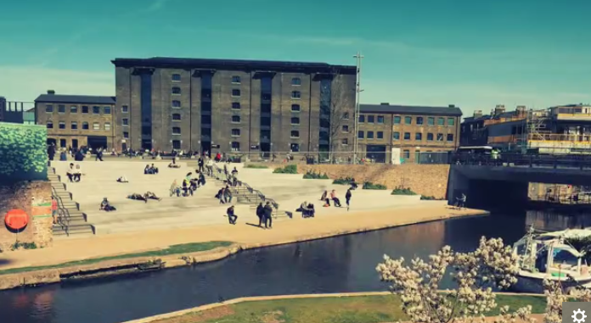
images
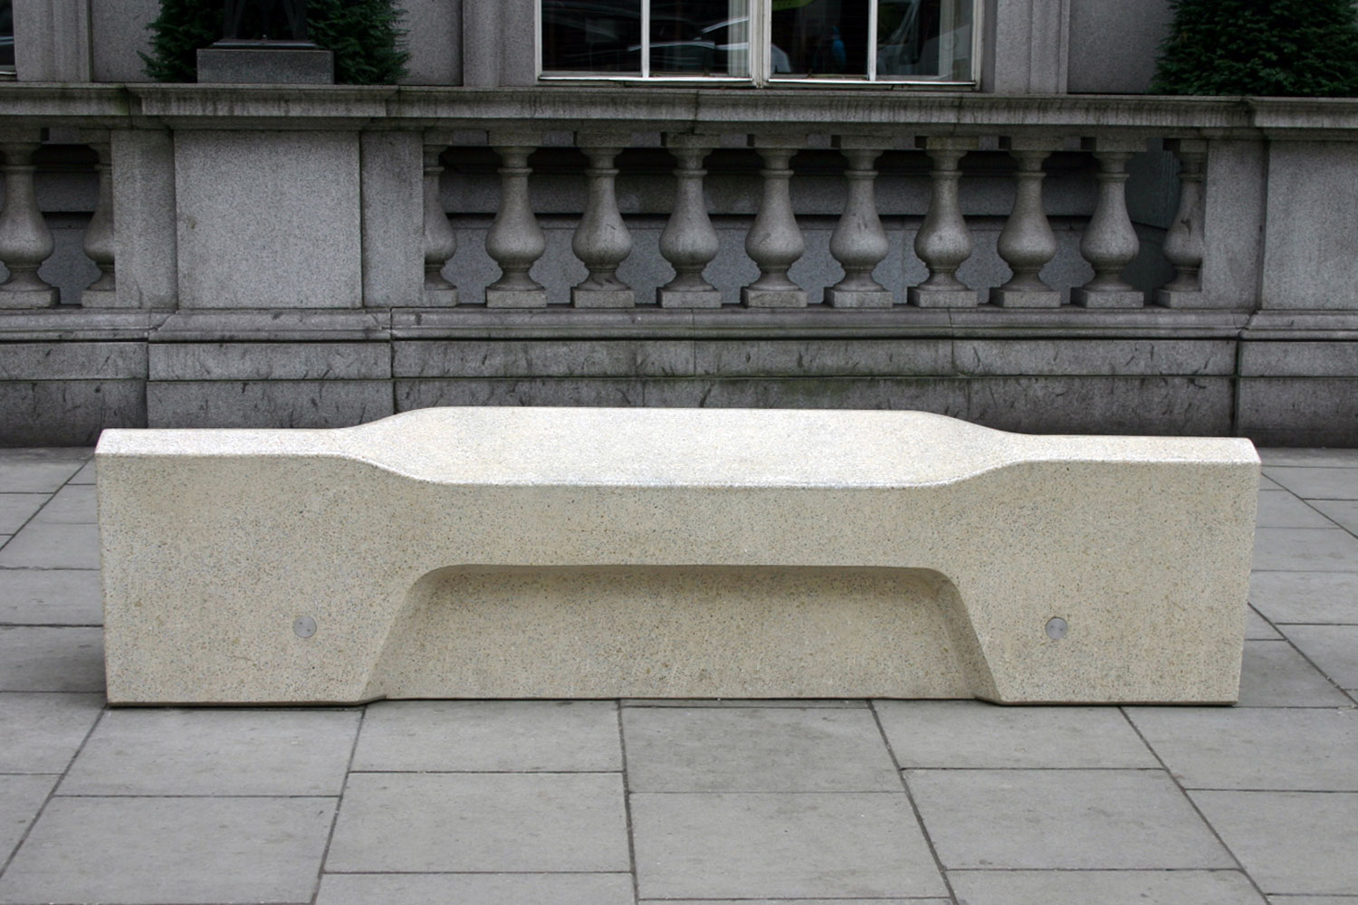
Figure 1: Gooden, N. (2015) Granary Square London. Available from: https://www.nicholasgooddenphotography.co.uk/london-blog/permit-for-photography-london. [accessed April 2017]
Figure 2: Factory Furniture (2012) Camden Bench. Available from: http://www.factoryfurniture.co.uk/camden-bench/ [accessed 21 April 2017]
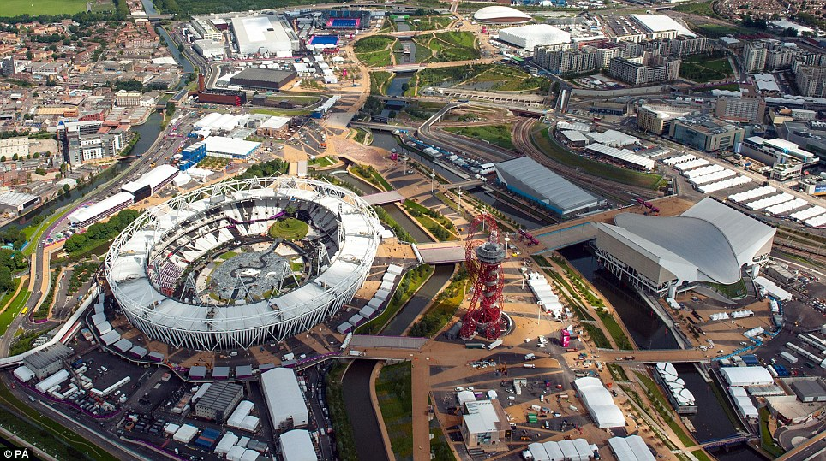
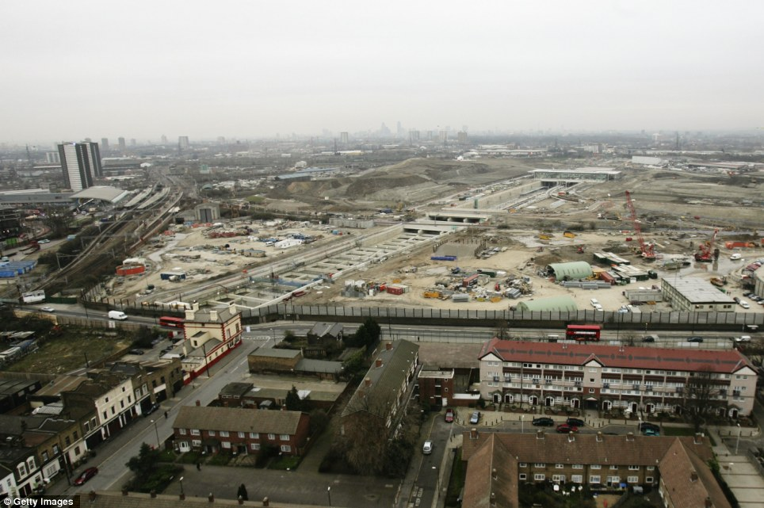
Figure 3: Getty Images, The barren wasteland in Stratford. Available from: http://www.dailymail.co.uk/news/article-2179912/London-2012-Stunning-images-showing-seven-year-transformation-Stratfords-Olympic-Park.html [accessed 21 April 2017]
Figure 4:PA (2012) Gleaming Olympic Park. Available from: http://www.dailymail.co.uk/news/article-2179912/London-2012-Stunning-images-showing-seven-year-transformation-Stratfords-Olympic-Park.html. [accessed 21 April 2017]

Bibliography:
Alter, L. (2015) Is London's Garden Bridge going to be public space or a police state? treehugger.com. Available from: https://www.treehugger.com/urban-design/londons-garden-bridge-public-facility-or-police-state.html [accessed 21 April 2017]
Barker, S. (2017) Video: Lincoln students protest for free speech. Lincoln: The Lincolnite. Available from: http://thelincolnite.co.uk/2017/03/video-lincoln-students-protest-free-speech/. [accessed 21 April 2017]
BBC (2013) London 2012 Olympics 'have boosted UK economy by £9.9bn'. London: BBC. Available from http://www.bbc.co.uk/news/uk-23370270. [accessed 21 April 2017]
Bloomfield, R. (2016) London house prices: Stratford outperforms the rest of London with up to 71 per cent growth since 2005. London: Evening Standard Homes & Property. Available from: http://www.homesandproperty.co.uk/property-news/buying/london-house-prices-stratford-outperforms-the-rest-of-the-capital-with-up-to-70-per-cent-growth-a99061.html . [accessed 21 April 2017]
Byass, R. (2010) From public garden to corporate plaza, Piccadilly Gardens and the new civic landscape. Journal of Landscape Architecture. Spring 2010,

Dugan, E. (2013) Olympics legacy: Did the Games succeed in rejuvenating East London? London: The Independent. Available from: http://www.independent.co.uk/sport/olympics/olympics-legacy-did-the-games-succeed-in-rejuvenating-east-london-8711691.html. [accessed 21 April 2017]
Dunn, J. (2015) No kites, no speeches and no musical instruments: The bizarrely strict set of rules planned for London's Garden Bridge. London: Daily Mail. Available from: http://www.dailymail.co.uk/news/article-3308412/No-kites-no-speeches-no-musical-instruments-bizarrely-strict-set-rules-planned-London-s-Garden-Bridge.html#ixzz4evBqgfLW [accessed 21 April 2017]

Estates & Campus Services. Property Management. Lincoln: Estates and campus services. Available from: http://estates.lincoln.ac.uk/services/property-management/. [accessed 21 April 2017]
Garratt, B. (2015) The privatisation of cities' public spaces is escalating. It is time to take a stand. London: The Guardian. Available from https://www.theguardian.com/cities/2015/aug/04/pops-privately-owned-public-space-cities-direct-action [accessed 13 April 2017]

Gavron, N. (2011) Public life in private hands, Managing London’s public space. London: Greater London Authority. Available from: https://www.london.gov.uk/sites/default/files/gla_migrate_files_destination/Public%20space%20June%202011%20Webme.pdf
[accessed 21 April 2017]
Gooden, N (2015) Permit for Photography – London [blog] Available from: https://www.nicholasgooddenphotography.co.uk/london-blog/permit-for-photography-london [accessed 13 April 2017]
Little. S (2016) A park view could add a whopping £40,000 to the value of your house. what MORTGAGE. Available from: http://www.whatmortgage.co.uk/news/park-view-add-whopping-40000-value-house// [accessed 21 April 2017]
London Borough of Newham/Hackney/Tower Hamlets (2013) Byelaws for pleasure grounds, public walks and open spaces. Available from: http://www.queenelizabetholympicpark.co.uk/-/media/qeop/files/public/qeop-byelaws-pack-complete-version.ashx?la=en [accessed 21 April 2017]
Londonist (2015) What’s Next for Our Public Spaces. London: The Londonist. Available from http://londonist.com/2015/05/what-next-for-our-public-spaces. [accessed 21 April 2017]
LondonSE1.co.uk (2010) Photography restrictions outside City Hall ‘shocking’, London Assembly committee told. London: LondonSE1 Community Website. Available from: http://www.london-se1.co.uk/news/view/4960 [accessed 21 April 2017]
Mark, L. (2016) Campaigners take to streets over privatisation of public space. The Architects Journal. Available from: https://www.architectsjournal.co.uk/news/campaigners-take-to-streets-over-privatisation-of-public-space/10002884.article [accessed 21 April 2017]

McNulty, B. (2014) Desperately seeking the perfect swimming pool. London: The Telegraph. Available from: http://www.telegraph.co.uk/culture/art/architecture/10684024/Desperately-seeking-the-perfect-swimming-pool.html [accessed 21 April 2017]
Mitchell, D. (2003) The Right to the City: Social Justice and the Fight for Public Space. New York: The Guilford Press

Quinn, B. (2014) Anti-homeless spikes are part of a wider phenomenon of 'hostile architecture'. London: The Guardian. Available from: https://www.theguardian.com/artanddesign/2014/jun/13/anti-homeless-spikes-hostile-architecture. [accessed 21 April 2017]
Sackman, S. (2012) The Occupy London result raises the thorny issue of property v protest. London: The Guardian. Available from: https://www.theguardian.com/commentisfree/libertycentral/2012/jan/18/occupy-london-eviction-freedom-expression-private [accessed 21 April 2017]

Smithm, K (2012) Difference Between Public and Private Space. Available from: https://kailasmithemsociallanguagedigitalmedia.wordpress.com/2012/11/08/difference-between-public-and-private-space/ [accessed 21 April 2017]

Spacey, J. (2016) What is Hostile Architecture? Simplicable. Available from: http://simplicable.com/new/hostile-architecture. [accessed 21 April 2017]

Thomas, N. (2013) UK tourism hits record 12 months after Olympics. London: The Telegraph. Available from http://www.telegraph.co.uk/finance/newsbysector/retailandconsumer/leisure/10245796/UK-tourism-hits-record-12-months-after-Olympics.html. [accessed 21 April 2016]
Townsend, M. (2016) Will Self joins London ‘mass trespass’ over privatisation of public space. London: The Guardian. Available from: https://www.theguardian.com/uk-news/2016/feb/13/will-self-mass-trespass-london-protest. [accessed 21 April 2017]
Walker, J. (2017) “Like the Soviet Union or North Korea”: Lincoln MP hits out at Students’ Union Twitter gag. Lincoln: The Lincolnite. Available from: http://thelincolnite.co.uk/2017/03/like-soviet-union-north-korea-lincoln-mp-hits-students-union-twitter-gag/. [accessed 21 April 2017]

Walker, P. (2015) London Garden bridge users to have mobile phone signals tracked. London: The Guardian. Available from: https://www.theguardian.com/uk-news/2015/nov/06/garden-bridge-mobile-phone-signals-tracking-london [accessed 13 April 2017]

Woodward, J. (2017) Protest organised against SU over freedom of speech clampdown. Lincoln: The Linc. Available from: http://thelinc.co.uk/2017/03/protest-organised-against-su-over-freedom-of-speech-clampdown/. [accessed 21 April 2017]
Yorke, H. (2017) Student union bans Conservative society from speaking out - because they challenged its position on free speech. London: The Telegraph. Available from: http://www.telegraph.co.uk/education/2017/03/07/student-union-bans-conservative-society-speaking-challenged/. [accessed 21 April 2017]

APPENDIX 1 Security guard interview
12:30 20/03/2017. Conducted by William Dobie and Demi McCoid

Transcription:

What acts would get you kicked off campus immediately?
“Taking hard drugs on site, getting abusive to security and members of staff or other students, violating any of your terms and conditions found in your tenancy agreements.”

What would get you a warning?
“Sleeping on campus, can be asked to leave if caught twice
cannot drink on campus, unless attending one of the licensed locations on campus.”

What is the most common thing you see people doing that they’re not allowed to do?
“Smoking cannabis, especially around the courts.”

How often if at all do you escort people of the premises?
“Not very often, mostly members of the general public that are trying to steal bicycles. Bicycle theft is one of the most common crimes in Lincoln.”

Are protests permitted on campus?
“Not at all. They would be escorted of site.”

How long is CCTV data stored?
“31 days.”

How many cameras are there on campus?
“150-200 on campus. One of the most surveyed university campuses in the UK.”

How do you control the security of the buildings that 24 hours?
“We do patrols, hourly head counts, document students names using sign in sheets; 24 hours over the weekend and after 9pm on a weekday.”

What legal authority do you have to deal with people on campus?
“Only thing we can do as a security officer is citizen’s arrest - Which can be done by any member of public. We have no more legal authority than any other member of public. We are, however, in communication with the radio to the police. We act as more of visual deterrent on campus.”

What permission do you need in order to hand out leaflets and set up stalls on campus?
“You’ll need permission from the SU The security does not allow other private organisations such as Home night club and others to hand out flyers. They only allow quack to use the engine shed bridge.”

